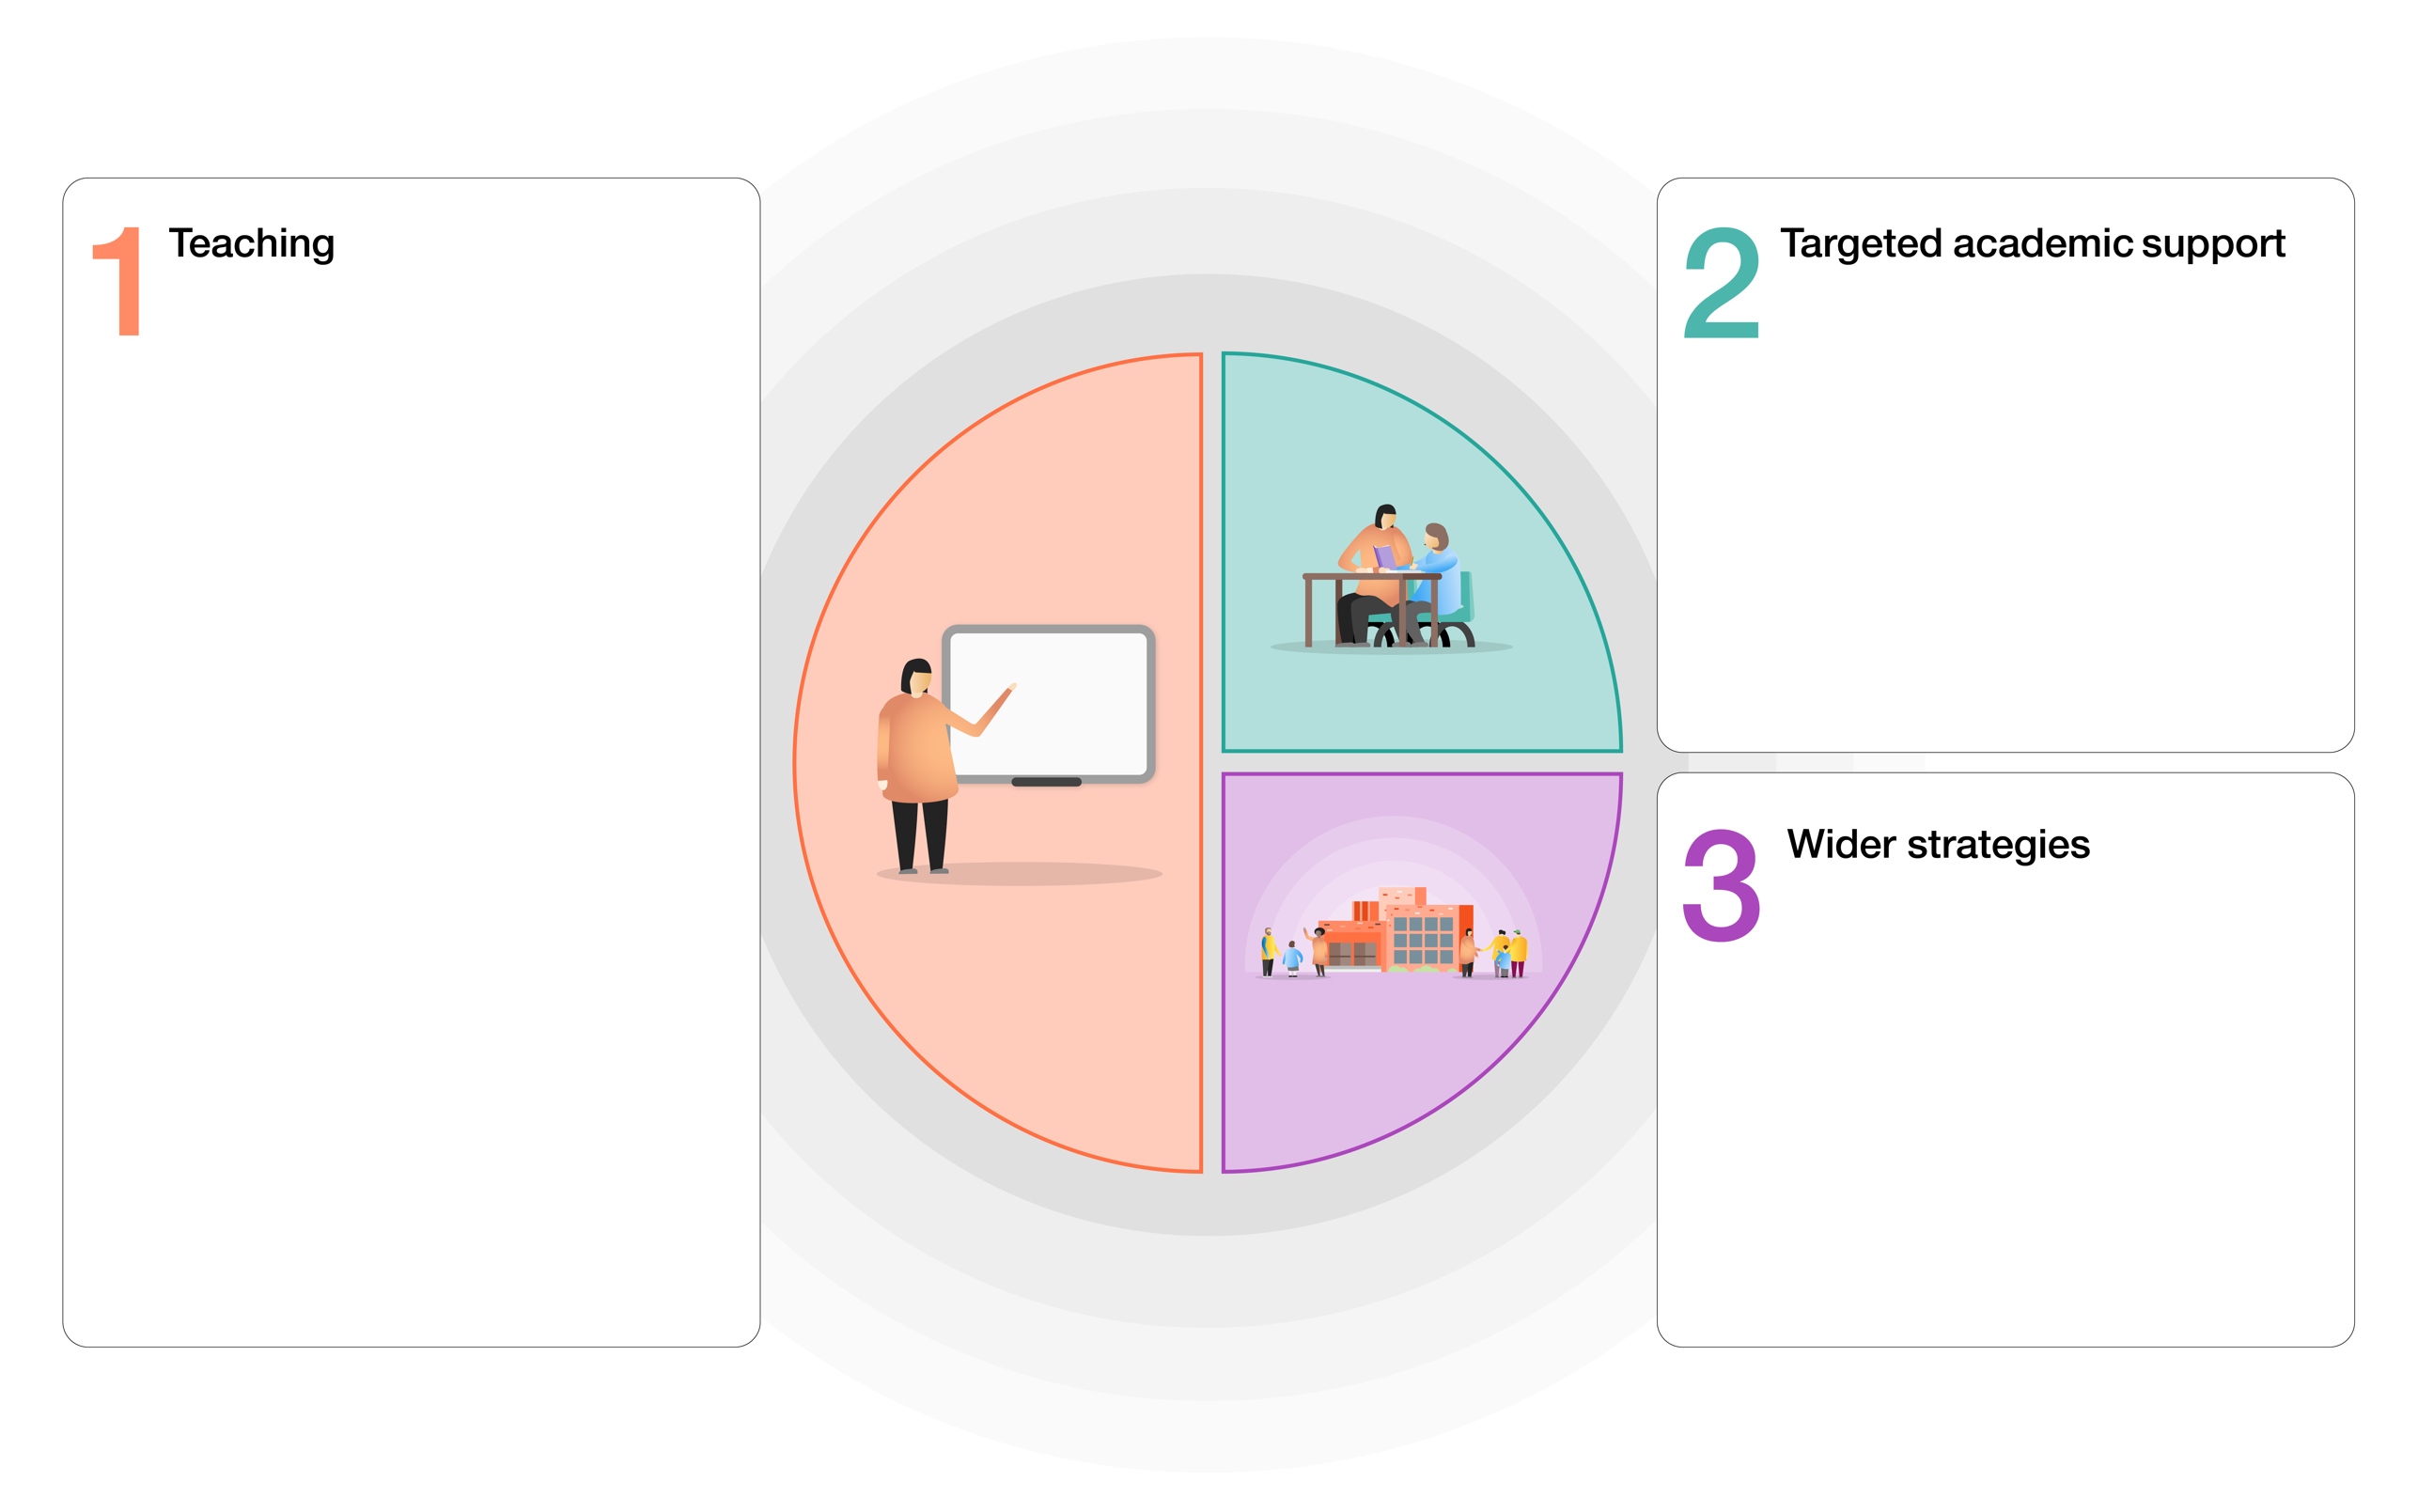

- Teachers need to carry out accurate and thorough assessment. Tools to support taking that information and identifying intervention strategies from it would support teachers with their next steps.
- Interventions should prioritise subjects which are hard to support remotely, e.g. writing, which suffered significantly during the last lockdown.

- It’s clear that accurate, diagnostic and systematic assessment of children’s knowledge (in reading and maths particularly) is needed. At present, the school uses teacher assessment primarily but this could be supported by summative tests specifically targeted at year group objectives.
- More resources are needed which enable pupils to become independent of the class teacher. Text books and workbooks can provide clear instruction and progressive questions which allow children to work more independently.
- Teachers need more technological support in order to teach remotely. Video software, ‘visualisers’ and microphones/webcams can help teachers to provide quality explanations and feedback.

- Staverton pupils need opportunities to connect with school and home, with events and initiatives which demonstrate that children belong and are valued.
- Opportunities to express themselves socially and emotionally need to be planned into the curriculum.

Item | Rationale | Cost
Total fund available = £19,980
Maths on Target-workbooks, worksheets and text books for Every Child from Year 1-6  CGP work books for Years 4, 5 and 6 | - Provide high-quality questions and learning for children in both school and home.  - Questions based on year group national curriculum and provide both support and challenge with effective differentiation  - Answers can be provided so pupils can self-mark.  - Text books can provide immediate learning if pupils are required to self-isolate away from their bubble.  - School will continue to use these resources when school reopens.  - Support for children at home which requires little or no technology. | £2089.57  £150.70
English Text books and resources for Every Child from Year 1-6  Poetry book for every class | - Provide high-quality questions and learning for children in both school and home.  - Questions based on year group national curriculum and provide both support and challenge with effective differentiation  - Answers can be provided so pupils can self-mark.  - Text books can provide immediate learning if pupils are required to self-isolate away from their bubble.  - School will continue to use these resources when school reopens.  - Support for children at home which requires little or no technology. | £2,000  £157.32
A ukulele for every child in the school  Resources to support practising at home | - Provides much needed expressive arts support for children.  - A chance to build connections between those at school and those at home.  - A long-term project which encourages resilience and practice  - Learning away from screens | £4030  (-£500 from Wiltshire Music Fund)  £3530
High quality books for every reading corner in the school | - Adopting a culture of reading for pleasure the best way to improve children’s progress  - Texts which help children to process children’s thoughts, feelings and emotions.  - Increasing children’s vocabulary and knowledge. | £5,000  (£500 per book corner)
NTS assessments for years 1-6 | - Accurate diagnostic assessment of each child 3 x per year for reading and maths.  - Thorough intervention strategies and recommended activities included for each year group objective  - Rebuild children’s resilience for assessments | £2,074.00
Visualisers and webcams | - To make high-quality explanations and demonstrations for the children.  - Children can get more immediate and visual feedback on their learning. | £498.87
£15500.46 committed so far

