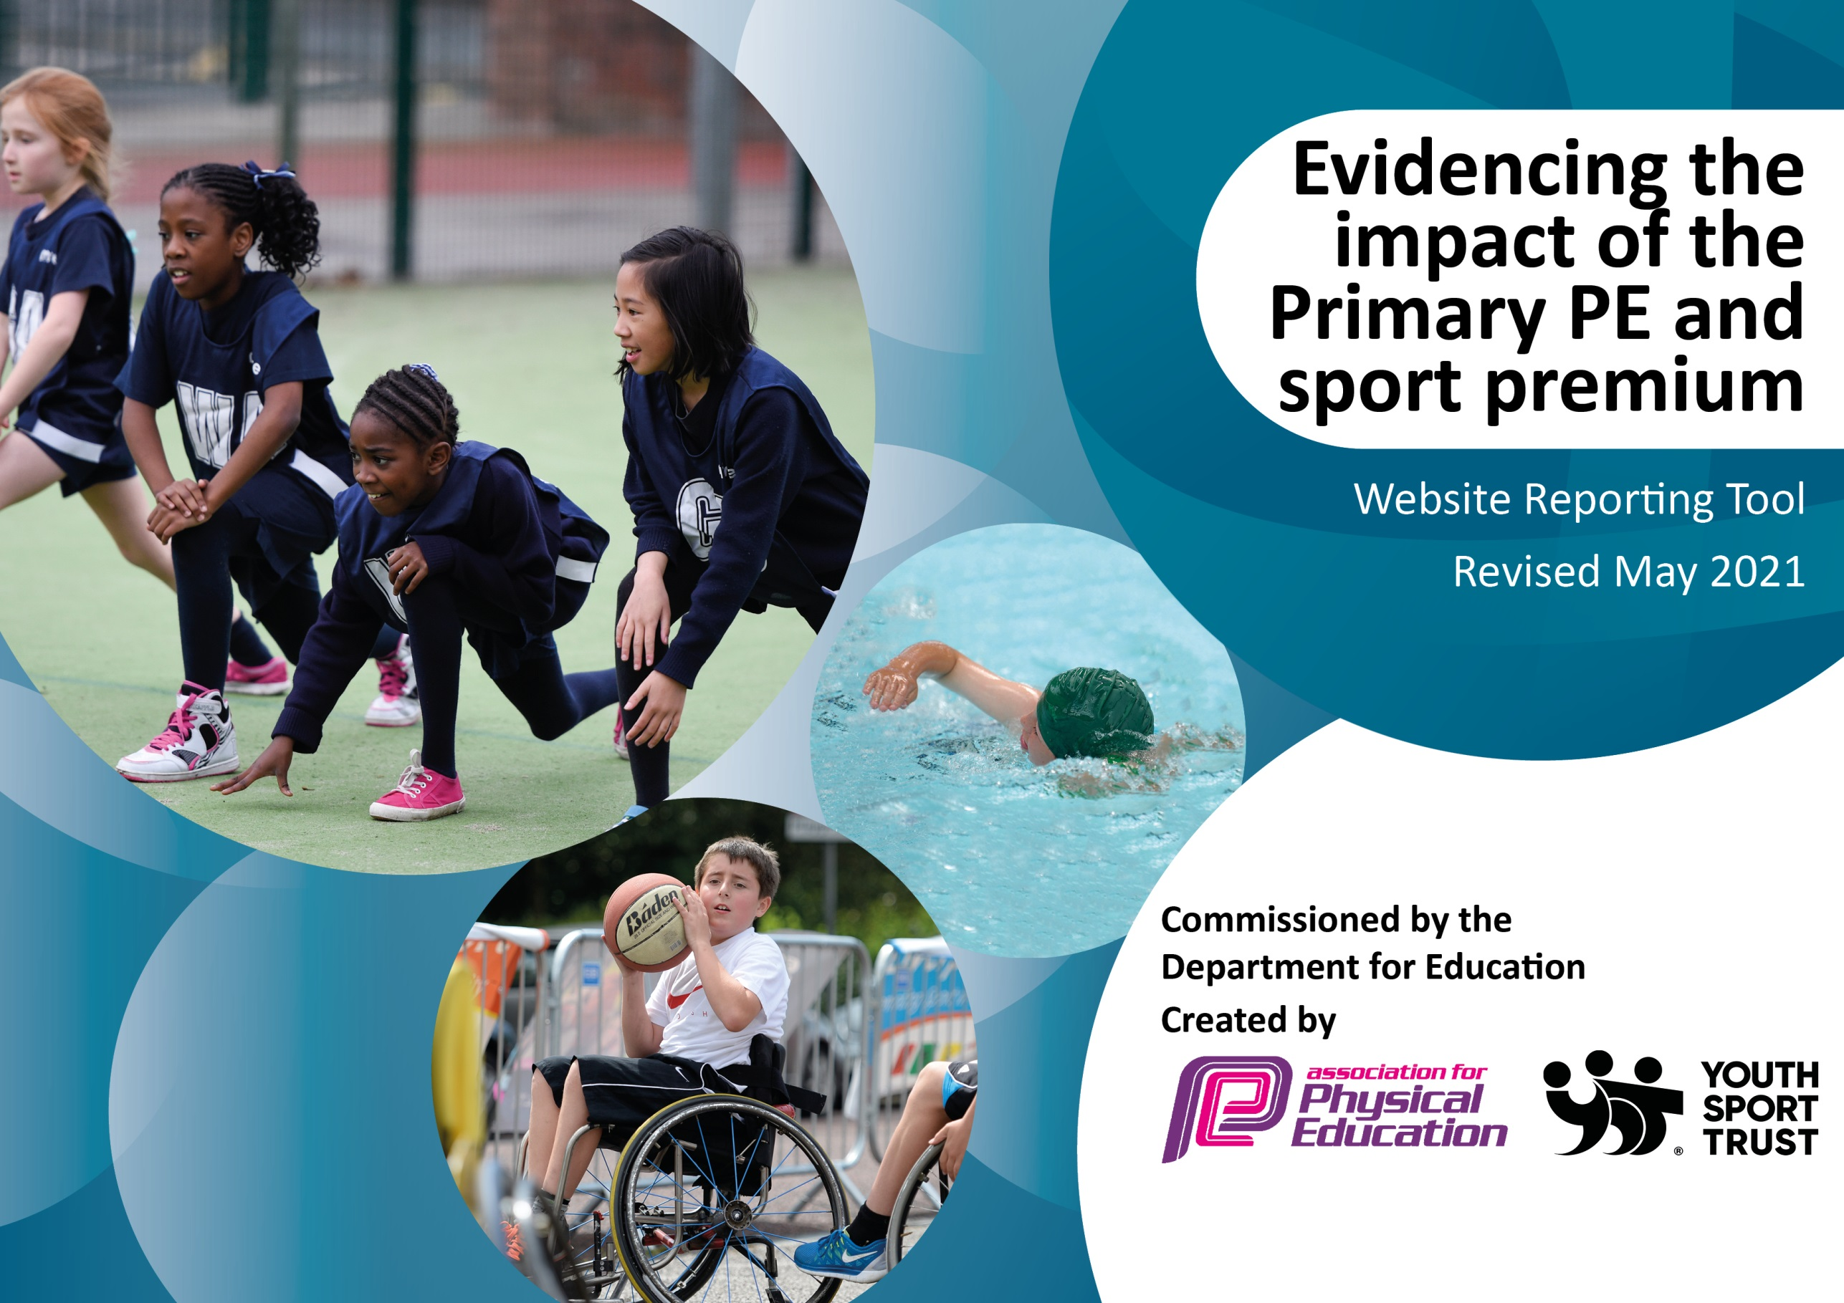

It is important that your grant is used effectively and based on school need. The Education Inspection Framework (Ofsted 2019 p64) makes clear there will be a focus on ‘whether leaders and those responsible for governors all understand their respective roles and perform these in a way that enhances the effectiveness of the school’.

Under the Quality of Education criteria (p41) inspectors consider the extent to which schools can articulate their curriculum (INTENT), construct their curriculum (IMPLEMENTATION) and demonstrate the outcomes which result (IMPACT).

To assist schools with common transferable language this template has been developed to utilise the same three headings which should make your plans easily transferable between working documents.

Schools must use the funding to make additional and sustainable improvements to the quality of Physical Education, School Sport and Physical Activity (PESSPA) they offer. This means that you should use the Primary PE and sport premium to:

- Develop or add to the PESSPA activities that your school already offer
- Build capacity and capability within the school to ensure that improvements made now will benefit pupils joining the school in future years
- The Primary PE and sport premium should not be used to fund capital spend projects; the school’s budget should fund these.
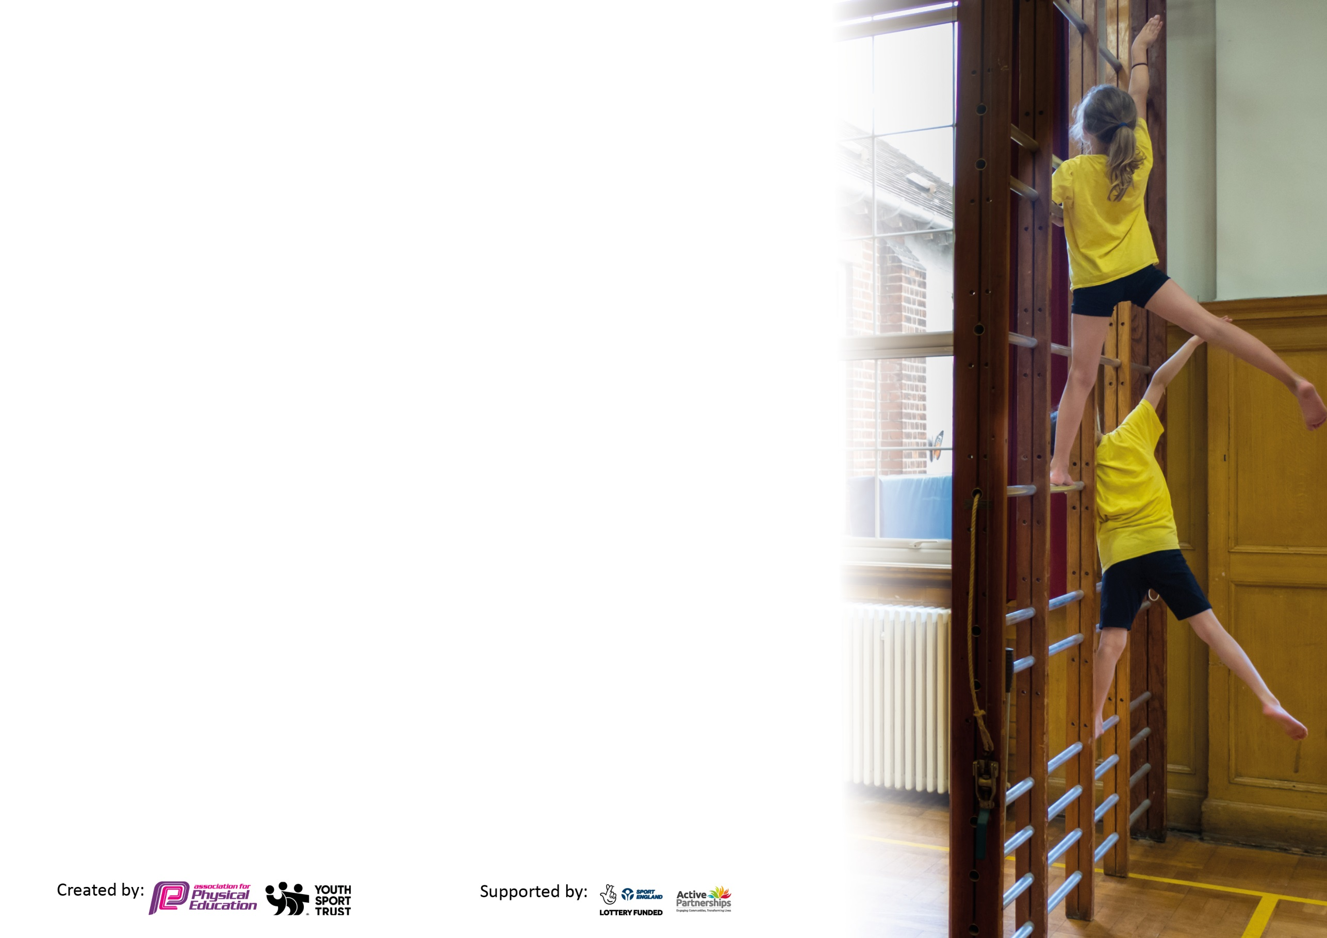
Please visit gov.uk for the revised DfE guidance including the 5 key indicators across which schools should demonstrate an improvement. This document will help you to review your provision and to report your spend. DfE encourages schools to use this template as an effective way of meeting the reporting requirements of the Primary PE and sport premium.

We recommend you start by reflecting on the impact of current provision and reviewing the previous spend.

Schools are required to publish details of how they spend this funding, including any under-spend from 2019/2020, as well as on the impact it has on pupils’ PE and sport participation and attainment by the end of the summer term or by 31st July 2021 at the latest.

We recommend regularly updating the table and publishing it on your website throughout the year. This evidences your ongoing self-evaluation of how you are using the funding to secure maximum, sustainable impact. Final copy must be posted on your website by the end of the academic year and no later than the 31st July 2021. To see an example of how to complete the table please click HERE.

Please note: Although there has been considerable disruption in 2020 it is important that you publish details on your website of how you spend the funding - this is a legal requirement.
Support for review and reflection - considering the 5 key indicators from DfE, what development needs are a priority for your setting and your pupils now and why? Use the space below to reflect on previous spend and key achievements and areas for development.

N.B. In this section you should refer to any adjustments you might have made due to Covid-19 and how these will influence further improvement.
Key achievements to date until July 2020: | Areas for further improvement and baseline evidence of need:
- New Early Years playground  - Outdoor learning environment improved  - New PE scheme involving training of staff  - Audit of PE resources  - Parent survey about clubs | - Pride in PE – participation and appearance  - Teachers competency  - Increased opportunities of clubs and wider extra-curricular  - Whole school shared events  - Competition – within school and with other schools  - Wider community involvement

Did you carry forward an underspend from 2019-20 academic year into the current academic year? YES Delete as applicable
Total amount carried forward from 2019/2020 £10,887
+ Total amount for this academic year 2020/2021 £18,273
= Total to be spent by 31st July 2021 £29,160

Meeting national curriculum requirements for swimming and water safety.

N.B Complete this section to your best ability. For example you might have practised safe self-rescue techniques on dry land which you can transfer to the pool when school swimming restarts.
Due to exceptional circumstances priority should be given to ensuring that pupils can perform safe self rescue even
if they do not fully meet the first two requirements of the NC programme of study.
What percentage of your current Year 6 cohort swim competently, confidently and proficiently over a distance of at least 25 metres?  N.B. Even though your pupils may swim in another year please report on their attainment on leaving primary school at the end of the summer term 2021.  Please see note above. | Due to ‘COVID-19’, data could not be added.
What percentage of your current Year 6 cohort use a range of strokes effectively [for example, front crawl, backstroke and breaststroke]?  Please see note above. | Due to ‘COVID-19’, data could not be added.
What percentage of your current Year 6 cohort perform safe self-rescue in different water-based situations? | Due to ‘COVID-19’, data could not be added.
Schools can choose to use the Primary PE and sport premium to provide additional provision for swimming but this must be for activity over and above the national curriculum requirements. Have you used it in this way? | No

Action Plan and Budget Tracking
Capture your intended annual spend against the 5 key indicators. Clarify the success criteria and evidence of impact that you intend to measure to evaluate for pupils today and for the future.

Academic Year: 2020/21 | Total fund allocated: £29,160 | Date Updated:
Key indicator 1: The engagement of all pupils in regular physical activity – Chief Medical Officers guidelines recommend that primary school pupils undertake at least 30 minutes of physical activity a day in school |  |  |  | Percentage of total allocation:
 |  |  |  | 80%
Intent | Implementation |  | Impact
Your school focus should be clear what you want the pupils to know and be able to do and about  what they need to learn and to  consolidate through practice: | Make sure your actions to achieve are linked to your intentions: | Funding allocated: | Evidence of impact: what do pupils now know and what can they now do? What has changed? | Sustainability and suggested next steps:
To increase children’s physical activity outside of regular PE lessons (including break and lunchtimes) in order to meet government guidelines  To ensure all pupils continue to receive high quality PE lessons. | - New playground for KS1  - New sports equipment that can be used at break and lunchtimes  - Organise sport shed in KS2 playground to make playtime equipment more accessible for the children  - New PE scheme – realPE. Training for teachers  - Introduce wake and shake  - Outdoor learning  - Outdoor gym on the KS2 playground  - Year 5 as trained sports ambassadors | £11,553  £1711  £9945 | - Observations at playtime show that more children are more active and using more equipment  - Breakfast club and after-school club more active by using the playground and equipment  - Children are using the play equipment effectively  - Staff are upskilled due to the training and therefore improve teaching of PE for pupils. | - MDSA’s to lead an activity during lunchtime  - Ensure training for new staff on realPE scheme  - Cycling proficiency for Year 6  - Ensure upkeep of new equipment  - Ask for pupils and staff voice about new equipment.  - Re-introduce play leaders to help with break and lunchtimes (Year 5 sports ambassadors to do this)
Key indicator 2: The profile of PESSPA being raised across the school as a tool for whole school improvement |  |  |  | Percentage of total allocation:
 |  |  |  | 10%
Intent | Implementation |  | Impact
Your school focus should be clear what you want the pupils to know and be able to do and about  what they need to learn and to  consolidate through practice: | Make sure your actions to achieve are linked to your intentions: | Funding allocated: | Evidence of impact: what do pupils now know and what can they now do? What has changed?: | Sustainability and suggested next steps:
To raise children’s awareness of fitness and physical activity through competition and skills-based activities. | - New scheme with a focus on skills– real PE  - New clubs  - External coaches delivering sessions (cricket and rugby).  - Sports activities and competitions throughout sports week | £2290  £535 | - Increased participation in clubs across key stages  - All children accessed the decathlon during Sports Week | - More new clubs – some led by school staff and some externally run offered across both key stages  - Termly competitions across school  - Enter competitions with school sports teams  - PE/Play leaders in Year 6

Key indicator 3: Increased confidence, knowledge and skills of all staff in teaching PE and sport |  |  |  | Percentage of total allocation:
 |  |  |  | %
Intent | Implementation |  | Impact
Your school focus should be clear | Make sure your actions to | Funding | Evidence of impact: what do | Sustainability and suggested
what you want the pupils to know | achieve are linked to your | allocated: | pupils now know and what | next steps:
and be able to do and about | intentions: |  | can they now do? What has
what they need to learn and to |  |  | changed?:
consolidate through practice:
To provide quality PE and sports training to all teachers to increase confidence, knowledge and skills.  To ensure all new staff are supported in delivering high quality PE | - Twilight training sessions delivered by real PE  - Teachers to observe external rugby and cricket coaches | Inc. above | - Teachers now have a broad range of activities to draw upon in order to teach specific skills  - Teachers have a wider knowledge and skills set in relation to different sports and equipment | - Ensure all new staff are trained in realPE.  - PE lead to check in with staff regularly about PE lessons  - Staff CPD
Key indicator 4: Broader experience of a range of sports and activities offered to all pupils |  |  |  | Percentage of total allocation:
 |  |  |  | %
Intent | Implementation |  | Impact
Your school focus should be clear | Make sure your actions to | Funding | Evidence of impact: what do | Sustainability and suggested
what you want the pupils to know | achieve are linked to your | allocated: | pupils now know and what | next steps:
and be able to do and about | intentions: |  | can they now do? What has
what they need to learn and to |  |  | changed?:
consolidate through practice:
To provide children with a broader range of physical activities to challenge and inspire them. | - Parent survey about clubs at Staverton  - New PE scheme to offer challenge  - Range of clubs – rugby, golf, dance  - Forest school  - Sports week offered a chance to try a range of new sports and activities | Inc. above | - Aware of the types of clubs that children want and have timetabled these for new academic year  - Children that have participated in the clubs on offer have enjoyed them and would take part in them again | - Second parent survey and pupil voice survey about PE and clubs and make necessary changes in relation to this  - To expand sport opportunities  - When COVID restrictions allow, partake in competitions with other schools.  - Games afternoons  - Termly competition  - Cycling proficiency  - Ensure all children have the opportunity to participate in a range of clubs.

Key indicator 5: Increased participation in competitive sport |  |  |  | Percentage of total allocation:
 |  |  |  | 6%
Intent | Implementation |  | Impact
Your school focus should be clear | Make sure your actions to | Funding | Evidence of impact: what do | Sustainability and suggested
what you want the pupils to know | achieve are linked to your | allocated: | pupils now know and what | next steps:
and be able to do and about | intentions: |  | can they now do? What has
what they need to learn and to |  |  | changed?:
consolidate through practice:
To provide children with a wider range of competitive sporting opportunities. | - Enter school teams in as many events possible throughout the year  - More engagement with the School Games Mark  - To host a sports week that includes a sports day  - Within sports week, provide children with opportunities to try out different sports | £1671 | - Postponed due to COVID-19  - All children were involved within sports week and participated in a decathlon of different events | - Run more after school clubs to create school teams  - Develop links with local schools to arrange fixtures

Signed off by
Head Teacher: | E.Powe
Date: | 25/06/2021
Subject Leader: | K.Jefferys
Date: | 25/06/2021
Governor:
Date:

