Online Safety Parents meeting 1st March 2022 Useful websites

Internet Matters – latest safety advice about a variety of apps https://www.internetmatters.org/hub/?tab=apps-platforms
Various online safety guides keeping-children-safe/share-aware/

Lots of great resources for keeping safe online http://www.childnet.com/parents-and-carers

Training, resources and information for children, their families and those who work with them (you can choose the age when you enter the website)
http://www.thinkuknow.co.uk

Safer Internet –support you as you support your child to be safe online
https://saferinternet.org.uk/guide-and-resource/parents-and-carers

Packed with resources it is a great resource for parents.
https://www.childnet.com/parents-and-carers/

Please also visit our website (key info – online safety) to see more information.

Reporting websites
Report Harmful Content
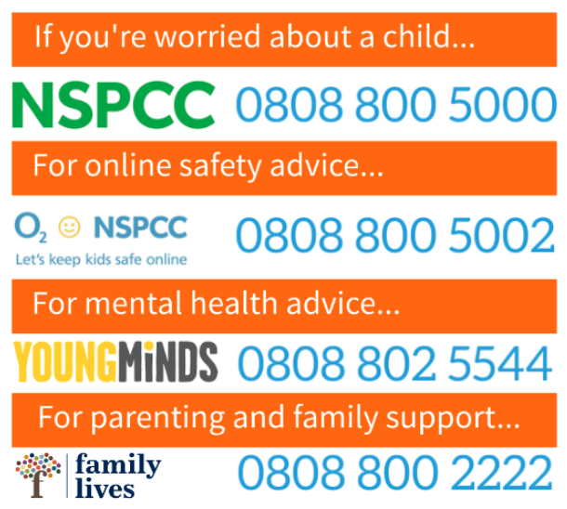
National Crime Agency: CEOP (Child Exploitation and Online Protection command)

