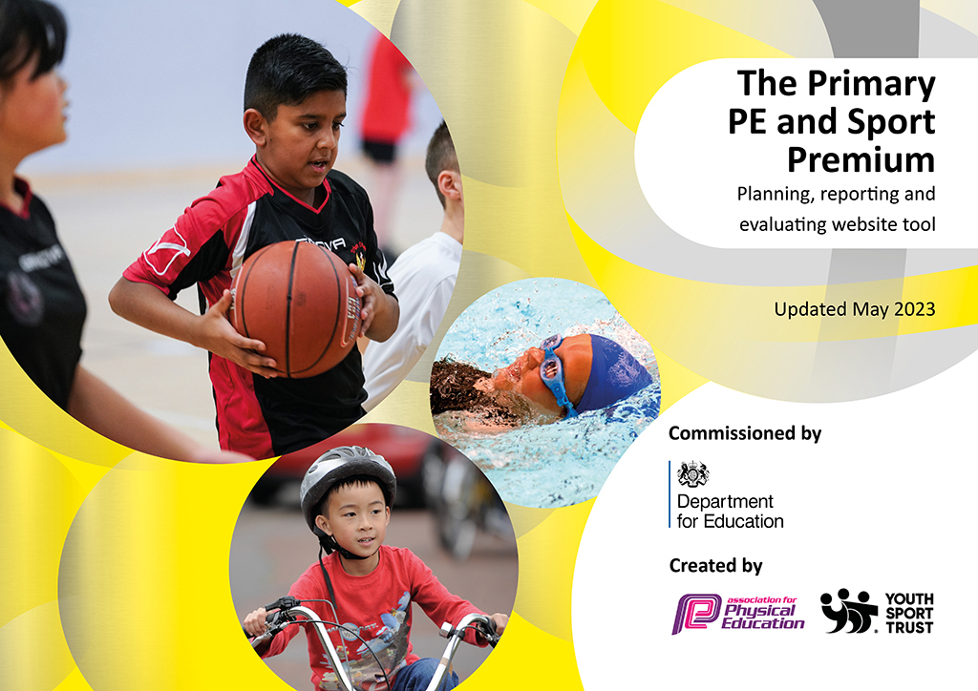
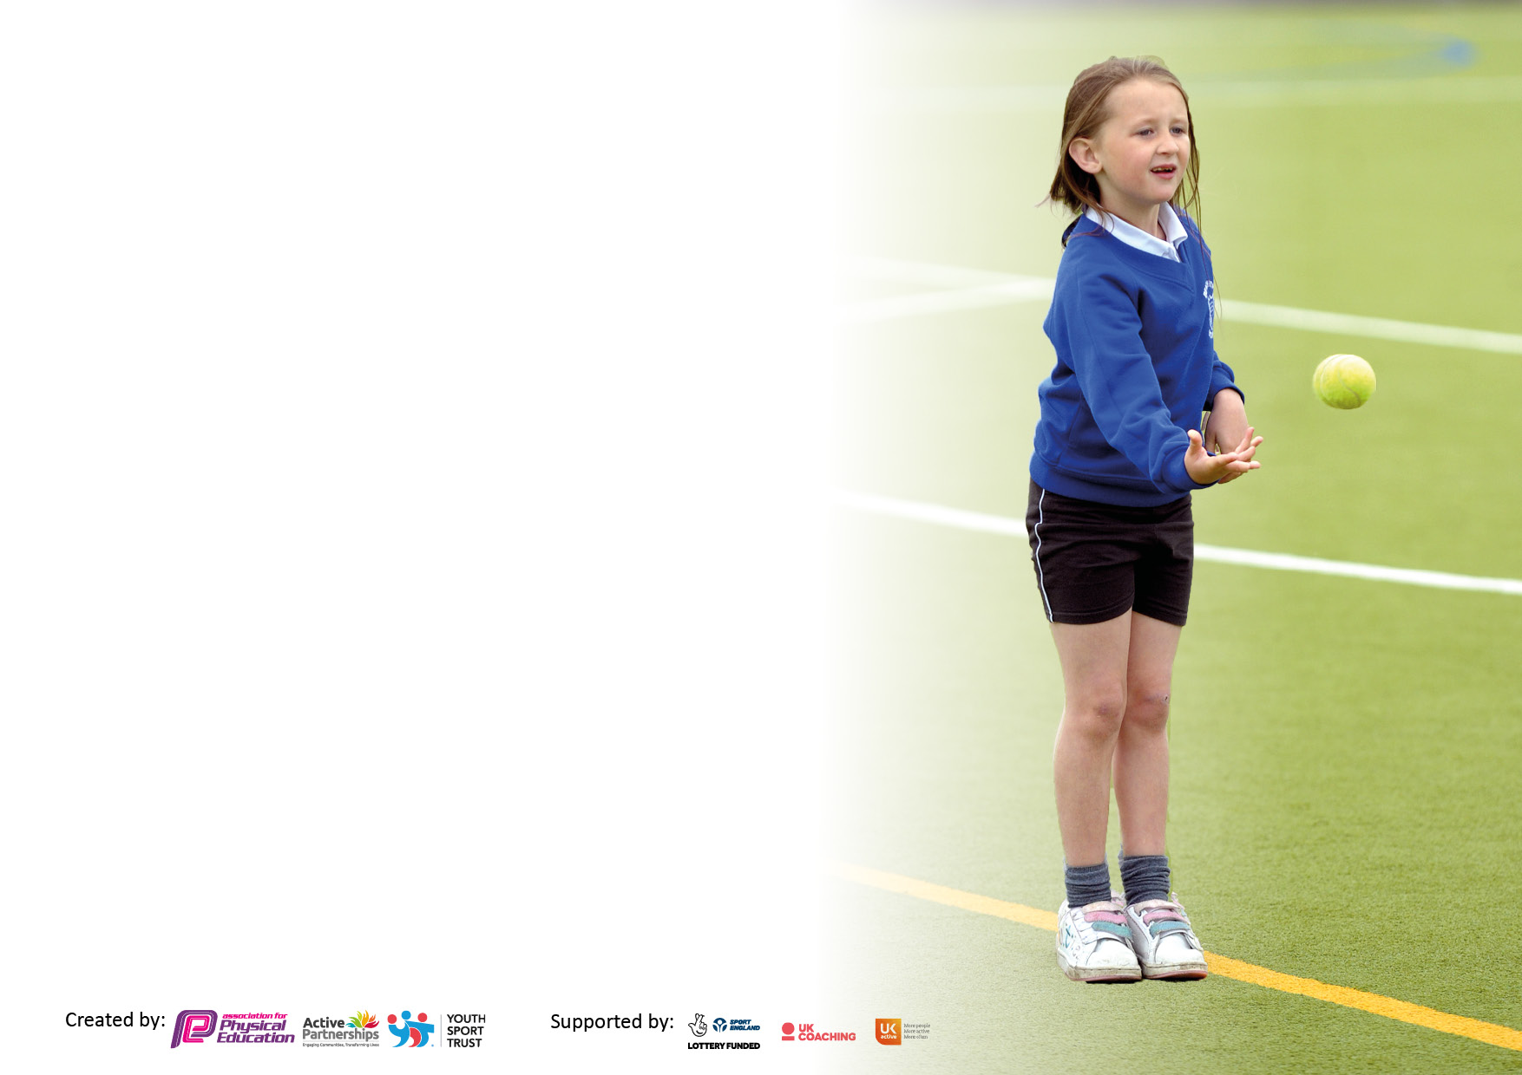

It is important that your grant is used effectively and based on school need. The Education Inspection Framework makes clear there will be a focus on ‘whether leaders and those responsible for governors all understand their respective roles and perform these in a way that enhances the effectiveness of the school’.

Under the Quality of Education Ofsted inspectors consider:
Intent - Curriculum design, coverage and appropriateness
Implementation - Curriculum delivery, Teaching (pedagogy) and Assessment
Impact - Attainment and progress

To assist schools with common transferable language this template has been developed to utilise the same three headings which should make your plans easily transferable between working documents.

Schools must use the funding to make additional and sustainable improvements to the quality of Physical Education, School Sport and Physical Activity (PESSPA) they offer. This means that you should use the Primary PE and sport premium to:

- Develop or add to the PESSPA activities that your school already offer
- Build capacity and capability within the school to ensure that improvements made now will benefit pupils joining the school in future years
- The Primary PE and sport premium should not be used to fund capital spend projects; the school’s budget should fund these.

Pleasevisitgov.ukfortherevisedDfEguidanceincludingthe5keyindicatorsacrosswhichschoolsshoulddemonstrate animprovement.Thisdocumentwillhelpyoutoreviewyourprovisionandtoreportyourspend.DfEencouragesschools to use this template as an effective way of meeting the reporting requirements of the Primary PE and Sport Premium.

We recommend you start by reflecting on the impact of current provision and reviewing the previous spend.

Schools are required to publish details of how they spend this funding, including any under-spend from 2021/2022, as well as on the impact it has on pupils’ PE and sport participation and attainment. All funding must be spent by 31st July 2023.

We recommend regularly updating the table and publishing it on your website throughout the year. This evidences your ongoing self-evaluation of how you are using the funding to secure maximum, sustainable impact. Final copy must be posted on your website by the end of the academic year and no later than the 31st July 2023. To see an example of how to complete the table please click HERE.

Details with regard to funding
Please complete the table below.

Total amount carried over from 2021/22 | £1455
Total amount allocated for 2021/22 | £19605
How much (if any) do you intend to carry over from this total fund into 2022/23? | £0
Total amount allocated for 2022/23 | £24190
Total amount of funding for 2023/23. To be spent and reported on by 31st July 2023. | £ 24190
Swimming Data
Please report on your Swimming Data below.

Meeting national curriculum requirements for swimming and water safety.

N.B. Complete this section to your best ability. For example you might have practised safe self-rescue techniques on dry land which you can then transfer to the pool when school swimming restarts.
Due to exceptional circumstances priority should be given to ensuring that pupils can perform safe self rescue even if they do not fully meet the first two requirements of the NC programme of study
What percentage of your current Year 6 cohort swim competently, confidently and proficiently over a distance of at least 25 metres?  N.B. Even though your pupils may swim in another year please report on their attainment on leaving primary school at the end of the summer term 2022.  Please see note above | 60%
What percentage of your current Year 6 cohort use a range of strokes effectively [for example, front crawl, backstroke and breaststroke]?  Please see note above | 60%
What percentage of your current Year 6 cohort perform safe self-rescue in different water-based situations? | 50%
Schools can choose to use the Primary PE and sport premium to provide additional provision for swimming but this must be for activity over and above the national curriculum requirements. Have you used it in this way? | No

Action Plan and Budget Tracking
Capture your intended annual spend against the 5 key indicators. Clarify the success criteria and evidence of impact that you intend to measure to evaluate for pupils today and for the future.

Academic Year: 2022/23 | Total fund allocated: | Date Updated:30/7/23
Key indicator 1: The engagement of all pupils in regular physical activity – Chief Medical Officers guidelines recommend that primary school pupils undertake at least 30 minutes of physical activity a day in school |  |  |  | Percentage of total allocation:
 |  |  |  | %45
Intent | Implementation |  | Impact
Your school focus should be clear what you want the pupils to know and be able to do and about  what they need to learn and to  consolidate through practice: | Make sure your actions to achieve are linked to your intentions: | Funding allocated: | Evidence of impact: what do pupils now know and what can they now do? What has changed?: | Sustainability and suggested next steps:
To increase children’s physical activity outside of regular PE lessons (including break and lunchtimes) in order to meet government guidelines  Develop an understanding of the importance of physical activity for a healthy lifestyle (physically and mentally) | - New sports equipment that can be used at break and lunchtimes  - Maintenance of sports hall facilities  - Artificial grass  - Gym equipment inspections  - Line markings on field for PE lessons and sports day  - Use of Staverton sports field for lessons, events and lunch times | £531.72  £1004.94  £7000  £70  £149.55  £2196.80 | - Observations at playtime show that more children are more active and using more equipment  - Breakfast club and after-school club more active by using the playground and equipment  - Children are using the play equipment effectively | -Have an MDSA dedicated to leading activities during break and lunch times.  -Further CPD for all staff on realPE scheme  -Year 5 sports leaders trained to help lead activities at lunch/break times
Key indicator 2: The profile of PESSPA being raised across the school as a tool for whole school improvement |  |  |  | Percentage of total allocation:
 |  |  |  | %3
Intent | Implementation |  | Impact
Your school focus should be clear what you want the pupils to know and be able to do and about  what they need to learn and to  consolidate through practice: | Make sure your actions to achieve are linked to your intentions: | Funding allocated: | Evidence of impact: what do pupils now know and what can they now do? What has changed?: | Sustainability and suggested next steps:
Develop an understanding of the importance of physical activity for a healthy lifestyle (physically and mentally.)  Ensure a variety of sports and activities are on offer to all. | Ensure daily physical activities in classes (brain breaks etc).  New clubs  Develop whole school resources. Physical and mental well-being through physical movement and exercise.  Sports activities and competitions throughout sports week. | Real PE scheme £695 | Increased participation in clubs across key stages  All children accessed the decathlon during Sports Week  Development of PE equipment to support the teaching of a variety of sports and extra-curricular activities such as netball, athletics, football, dodgeball.  Wide variety of sports to be taught as well as training the staff to further teach these sports/activities within the curriculum. | Sustainability: links with other schools to be continued and developed further.  Current year 5s trained to support play when moving up to year 6.  Next steps:  More new clubs – some led by school staff and some externally run offered across both key stages  More PE time allocated in curriculum (2 hours a week).  Ensure promotion of this and appropriate clothing for outside lessons, particularly during Winter.

Key indicator 3: Increased confidence, knowledge and skills of all staff in teaching PE and sport |  |  |  | Percentage of total allocation:
 |  |  |  | %12
Intent | Implementation |  | Impact
Your school focus should be clear | Make sure your actions to | Funding | Evidence of impact: what do | Sustainability and suggested
what you want the pupils to know | achieve are linked to your | allocated: | pupils now know and what | next steps:
and be able to do and about | intentions: |  | can they now do? What has
what they need to learn and to |  |  | changed?:
consolidate through practice:
We will provide quality PE and sports training to all teachers to increase confidence, knowledge and skills.  All new staff will be supported in delivering high quality PE. | RealPE CPD  PE lead to check in with staff regularly about PE lessons  Specialised coaching (Up and Under) – 2 terms per year group  Offering a wide variety of sports through curriculum, coaching and yoga  Support new staff and existing staff in the implementation and teaching of sport and physical activity. | Real PE CPD £545  Up and Under  £2394 | Staff are upskilled due to the training and therefore improve teaching of PE for pupils.  Teachers now have a broad range of activities to draw upon in order to teach specific skills  Teachers have a wider knowledge and skills set in relation to different sports and equipment  Specialised coaching has allowed for a wide variety of sports to be taught as well as training the staff to further teach these sports/activities within the curriculum | PE lead to check in with staff regularly about PE lessons  Teachers to continue to observe external coaches. Move focus to Team teach with them
Key indicator 4: Broader experience of a range of sports and activities offered to all pupils |  |  |  | Percentage of total allocation: 17
Intent | Implementation |  | Impact
Your school focus should be clear | Make sure your actions to | Funding | Evidence of impact: what do | Sustainability and suggested
what you want the pupils to know | achieve are linked to your | allocated: | pupils now know and what | next steps:
and be able to do and about | intentions: |  | can they now do? What has
what they need to learn and to |  |  | changed?:
consolidate through practice:
Are provided with a broader range of physical activities, including competition and skills-based, to challenge and inspire them  To develop a life-long love of sport and healthy active lifestyles.  Additional achievements:  - Range of clubs: golf, dance ,gymnastics, athletics, tennis, netball, football, etc. | RealPE scheme  Lunchtime provision  New clubs  External coaches: tennis, cricket,  -Dance festival for SEN children  -Badminton festival for PP children  - Range of clubs: golf, dance,gymnastics, dodgeball, athletics, tennis,  Sports week opportunity to participate in a range of sports: athletics, tennis, circus skills | See above  £3254.50  Freestyle footballer visit £1058 | Increased participation in clubs across key stages.  Increased number of children on the SEN register and DL participating in extra curricular activities. 44% of KS2 children on SEN register participated in at least one club this year.  48% of KS2 children on SEN register have participated in a competition/event with other schools.  Aware of the types of clubs that children want and have timetabled these for new academic year  Set up a yearly football competition with a local school. | Second parent survey and pupil voice survey about PE and clubs and make necessary changes in relation to this  Games afternoons  Termly competition

Key indicator 5: Increased participation in competitive sport |  |  |  | Percentage of total allocation:
 |  |  |  | %5
Intent | Implementation |  | Impact
Your school focus should be clear | Make sure your actions to | Funding | Evidence of impact: what do | Sustainability and suggested
what you want the pupils to know | achieve are linked to your | allocated: | pupils now know and what | next steps:
and be able to do and about | intentions: |  | can they now do? What has
what they need to learn and to |  |  | changed?:
consolidate through practice:
Are provided with a range of competitive sporting opportunities.  50% of all KS2 SEN children will participate in a club  50% of all KS2 SEN children will participate in a competition | New clubs  External coaches – Active Trowbridge, tennis, cricket, golf  Children given opportunities to try out different sports during sports week  Transport to and from events. | Transport £751  Collaborative schools membership £126  Supply to cover teachers at competitions £378.48 | Participation rates logged and monitored  All children competed in sports day decathlon and races | Run more after school clubs to create school teams. Ensure these are linked to competition schedule.  Develop links with local schools to arrange fixtures

Signed off by
Head Teacher:
Date:
Subject Leader: | L Smith
Date: | 30/7/2023
Governor:
Date:

