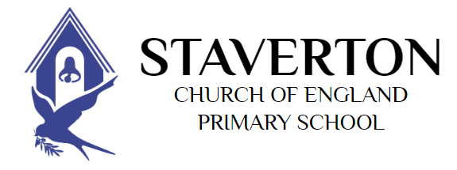

Policy on Religious Education
“A school without walls or ceilings.”
This policy is to be read in conjunction with the vision, values and distinct Christian character of the school. At the heart of our school is Jesus’ parable of the mustard seed where our principle values are explored:
Courage Kindness Respect Forgiveness Trust Hope.
Date policy was written: | June 2023
Record of reviews/amendments | July 2023-Ratified at FGB
Written by: | Debbie Moore (RE co-ordinator) In collaboration with staff, governors and Salisbury Diocese
Headteacher | Edward Powe
Chair of Governors | Jenny Smith
Date of next review | July 2025

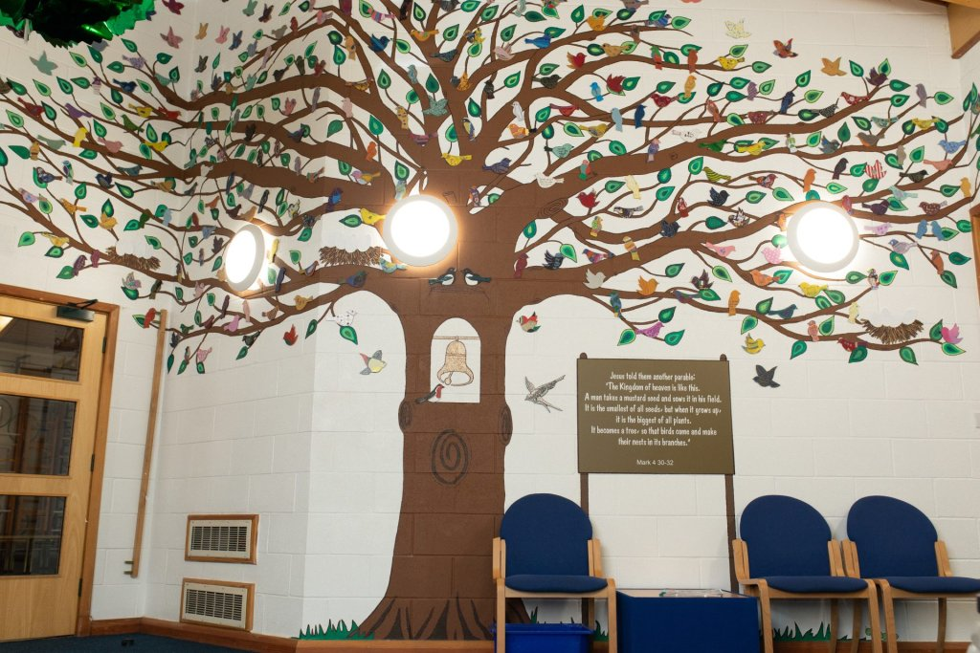

What is RE and why do we do it?
RE (Religious Education) is the study of world religions and beliefs. It is essential for a broad and balanced curriculum and supports the spiritual, moral, social and cultural development of the children. RE examines the deep meaning that individuals and groups make of their experiences and how this helps them give purpose to their lives. It provides opportunities to explore, make and respond to the meanings of those experiences in relation to the beliefs and experiences of others as well as to one’s own experiences.
RE is essential for allowing children to reflect on their own beliefs as well as the beliefs of others, experiencing how important questioning and understanding their views can impact on their belief system. By learning about a wide range of beliefs, children can explore and learn to understand how to respect someone else’s beliefs even if they do not personally hold the same views. At Staverton, we value each and every child, acknowledge that every child has their own point of view and accept them for who they are. We want children to leave Staverton holding the same level of respect for other faiths.

Aims of RE
- To be relevant for all children, whatever their religion or beliefs
- Teach understanding of world religions and beliefs as well as tolerance and compassion for other peoples’ view and faith
- Show how religion influences individuals, families, communities and cultures
- Explore the political and social impact of religion
- Encourage reflection on issues of justice and truth
- Provoke questions about the meaning of life
- Offer opportunities for personal reflection
- Develop and affirm personal identity and responsible citizenship
- Prepare children for adult life

What does RE look like at Staverton?
We teach RE in a blocked unit of 5-6 lessons. We have one unit of RE each term. Our units are either on Christianity or another world faith, with Christianity making up approximately half of our units.
The units on Christianity are taught through the scheme Understanding Christianity. This focuses on key themes and phases of the story within the Bible: Creation, People of God (Old Testament), Incarnation (Christmas), Gospel (Jesus’ life), Salvation (Easter), Kingdom of God (Christianity after Easter and today). Within each unit on Christianity we start by looking at the text and the key story of the unit. We then look at the impact of the story and values within the story on Christian’s lives today, before making connections between the values shown in the story and reflecting on their own views within the context of their life.
We teach several other world views throughout the curriculum as we want our children to have a broad understanding of different faiths. In KS1, this is focused on Islamic and Jewish faiths. In KS2, we have units which cover Islam, Judaism, Sikhism, Hinduism, Buddhism and Humanism (which covers agnostic and atheist world views). For other world views and faiths, we use a scheme called The Emmanuel Project. This focuses on a key concept or belief within the religion and uses an enquiry cycle, starting with Engaging, Enquiring, Exploring (the key text, the community practice and how they live this out), Evaluating, then Expressing their understanding.
Each unit in taught in line with our wider curriculum model. It has a key question for each unit, key pieces of knowledge that is taught, Skills that are developed throughout the unit, and an end product, where they can show us what they have learn throughout the unit. The RE is assessed through this end product and our knowledge based end of unit quiz.

Is religious education compulsory for pupils?
Staverton Primary School is a voluntary-controlled, Church of England school, maintained by the Wiltshire local education authority. We welcome admission from pupils from families with all faiths and none. We hope that our Christian vision and values are reflected in all that we do, in assembly, lessons, play and our relationships with each other.
It is important for families of pupils to recognize that religious education is an important part of the general education that the school provides. We understand that Christian religious beliefs and practices may be unfamiliar to a child or adult that does not either attend a church or has not been brought up in the Christian faith. School religious education is not a church Sunday School. Lessons are not a religious experience, a time for prayer or worship.
If you wish to withdraw your child from Religious Education, you have the right to do so. Please complete the last page of this policy and hand this into the school office (the page can be printed for you, if desired). Someone will be in touch with you to confirm your decision and tell you what the arrangements will be for your child during such lessons. It is likely that they would be supervised in the school library and be asked to sit quietly, occupying themselves. This would be for about 40 minutes.
Any staff member would prefer not to teach religious education, they are asked to speak with the Headteacher.

Staverton CE VC Primary School
Request to withdraw from the Religious Education part of the general curriculum
Your name
I ask that my child(ren)...
Your child(s) name(s)
...do not attend lessons in Religious Education from now on.
Date
If my decision changes, I will inform the School.
Signed
Please hand this form into the School Office.

Collective Worship
What is collective worship and why do we do it?
At Staverton CofE Primary School the children take part in a daily act of collective worship (also known as an assembly). As a church school, this is a requirement of the school to have a daily act of collective worship, but more importantly, it is a time within our busy school day, where we can come together and learn about important values for our lives. Collective worship teaches the children the importance of our Christian vision and values through stories, discussion and real-life examples. It also provides moments for children to be still, calm and reflective allowing children to grow spiritually.
Aims of collective worship
- Express praise and thanksgiving to God.
- Be still and reflect.
- Explore the big questions of life and respond to national events.
- Foster respect and deepen spiritual awareness.
- Reflect on the character of God and on the teachings of Christ.
- Affirm Christian values and attitudes.
- Share each other’s joys and challenges.
- Celebrate special times in the Christian calendar.
- Allows children to engage with the planning and leadership of collective worships.
- Encourage local partnerships with the local church community
- Appreciate worship in different ways: music, silence, story, prayer, reflection and other traditions of Anglican worship

